Assets:

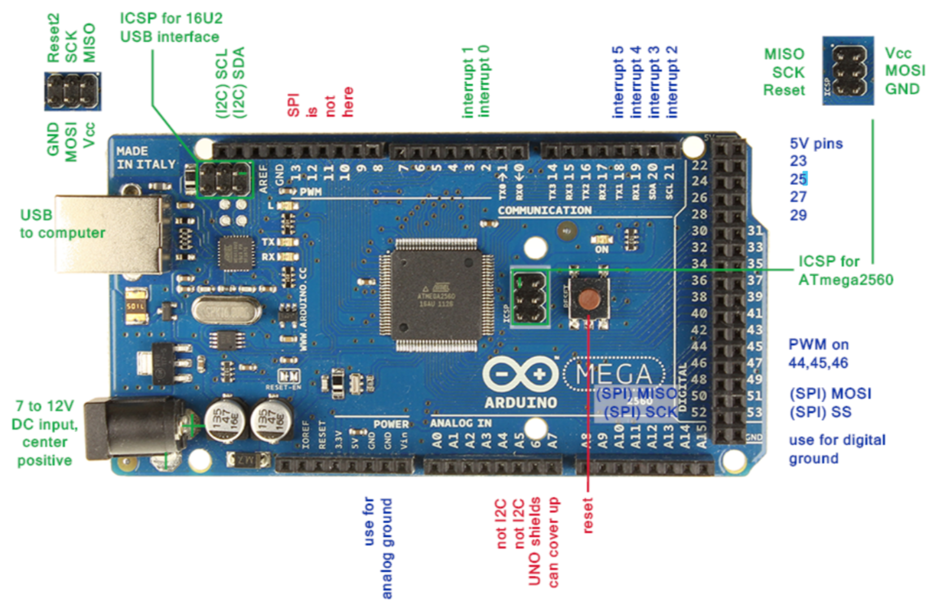

1. Burn HoodLoader at 16u2:

Burn 16u2 from m2560: <https://github.com/NicoHood/HoodLoader2/wiki/Installation-sketch-%28standalone-Arduino-Uno-Mega%29>

1. Upload Lights Thrill firmware at m2560:

<https://github.com/NicoHood/HoodLoader2/wiki/Uploading-programs>

IDE Config:

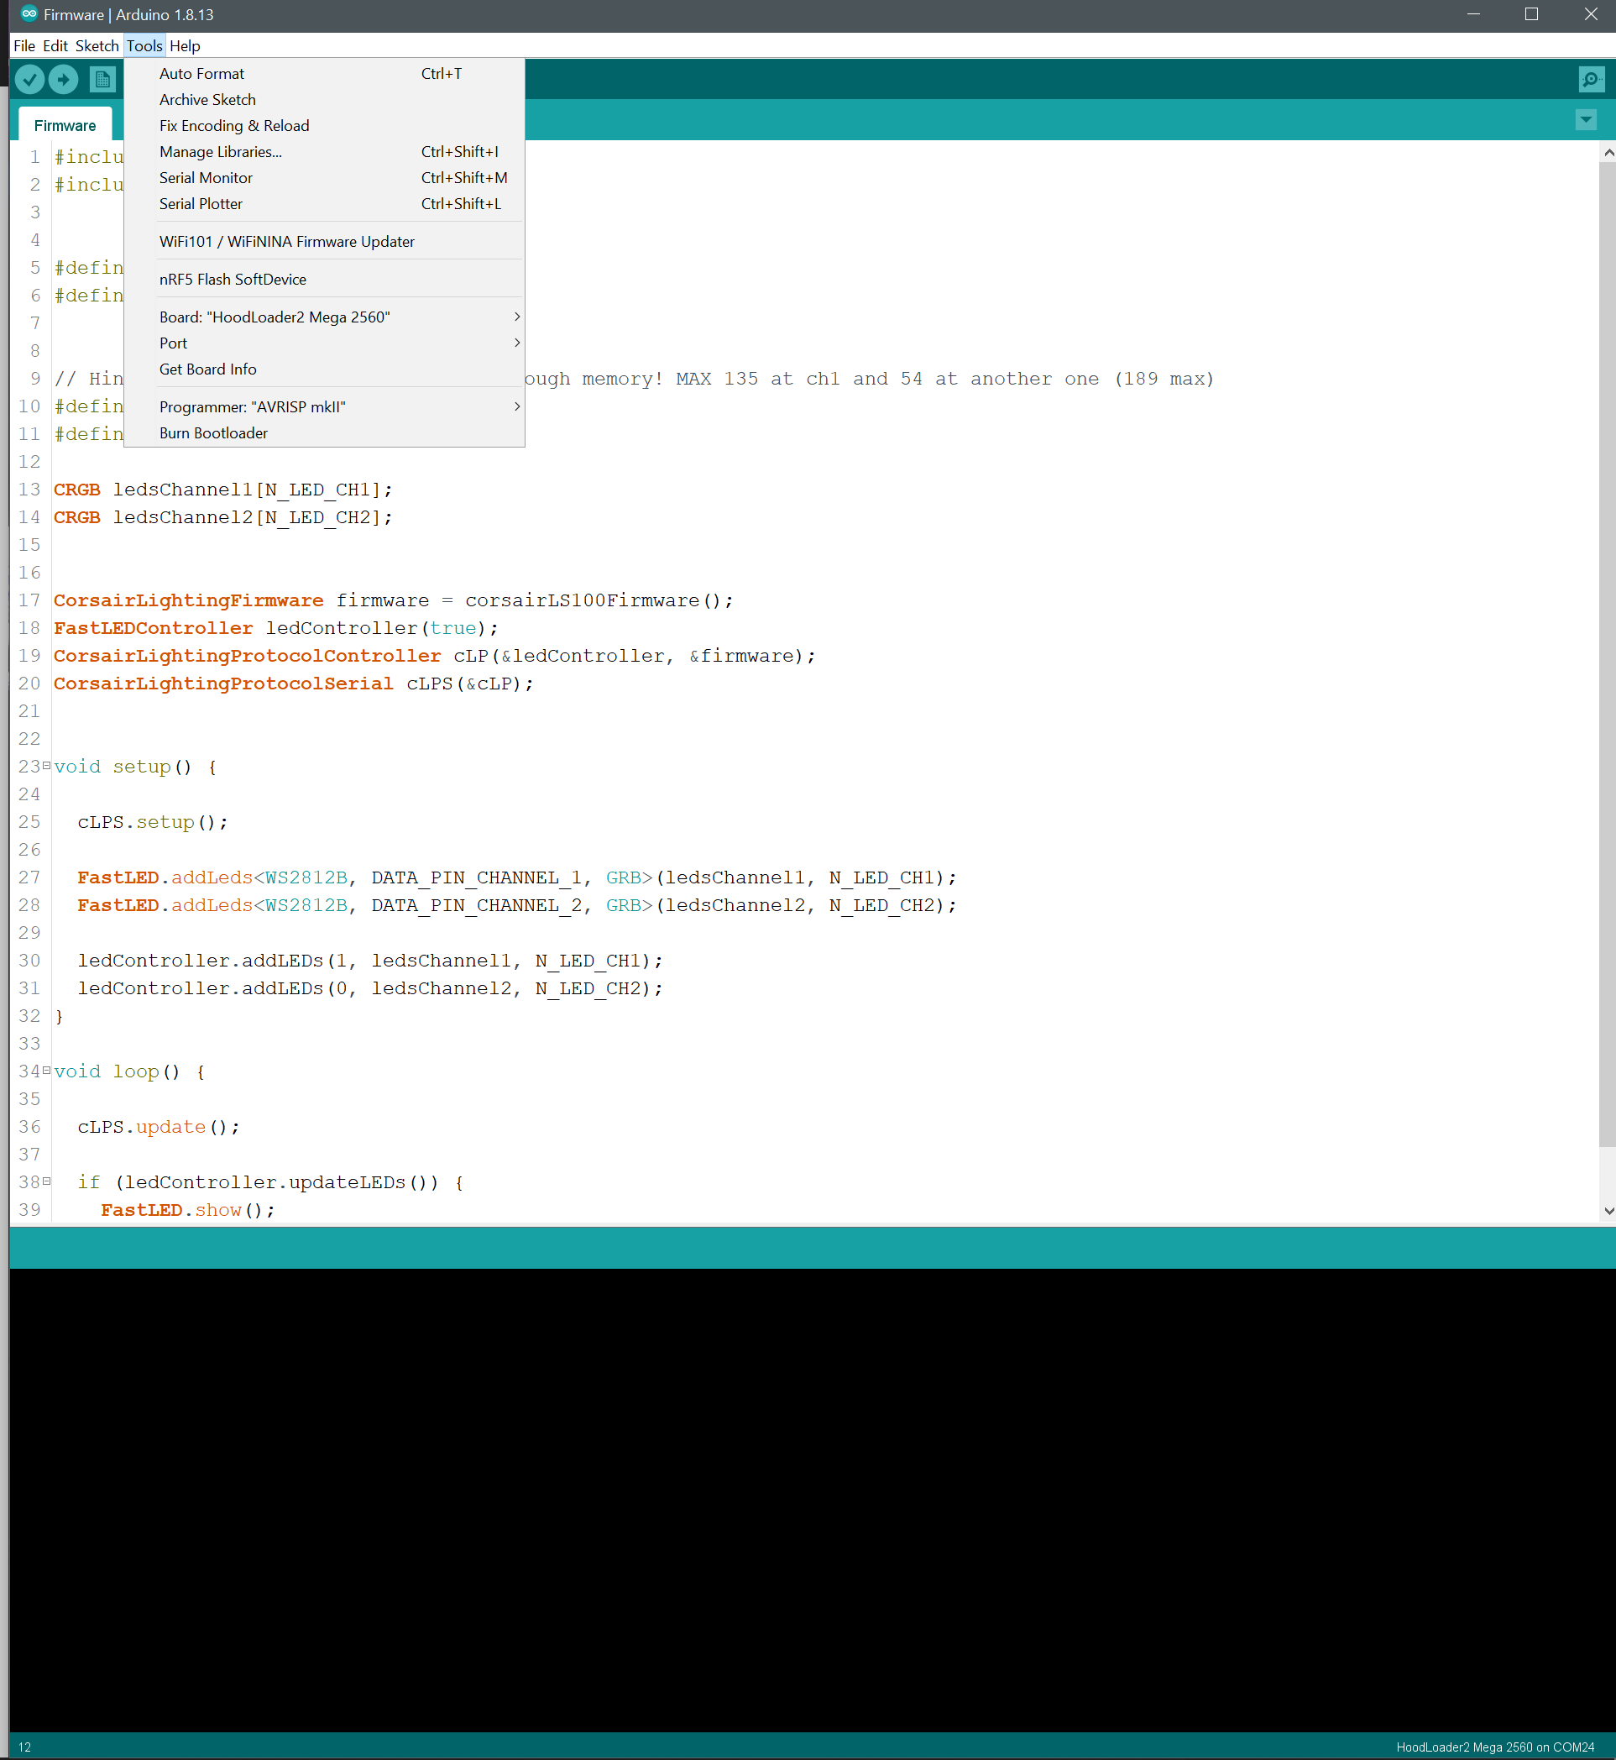

1. Upload the HoodLoader2CLPBridge to the 16u2:

<https://github.com/Legion2/CorsairLightingProtocol/wiki/How-to-use-on-Arduino-Uno-and-Arduino-Mega>

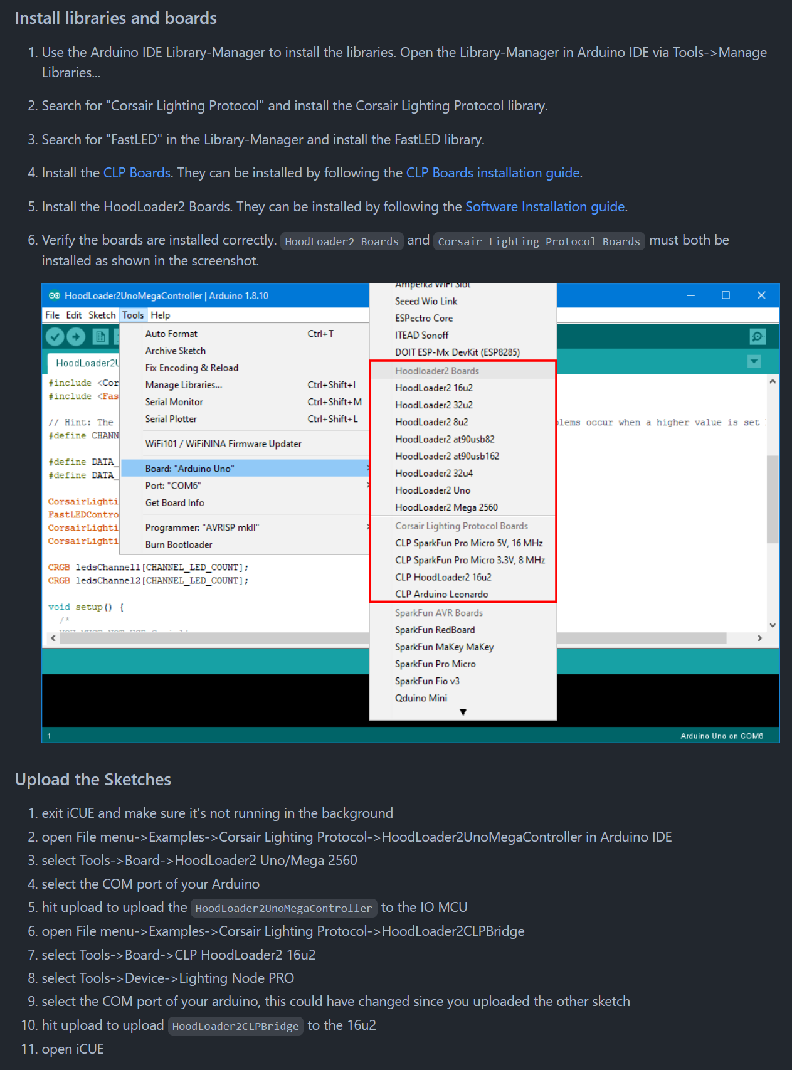

IDE config:

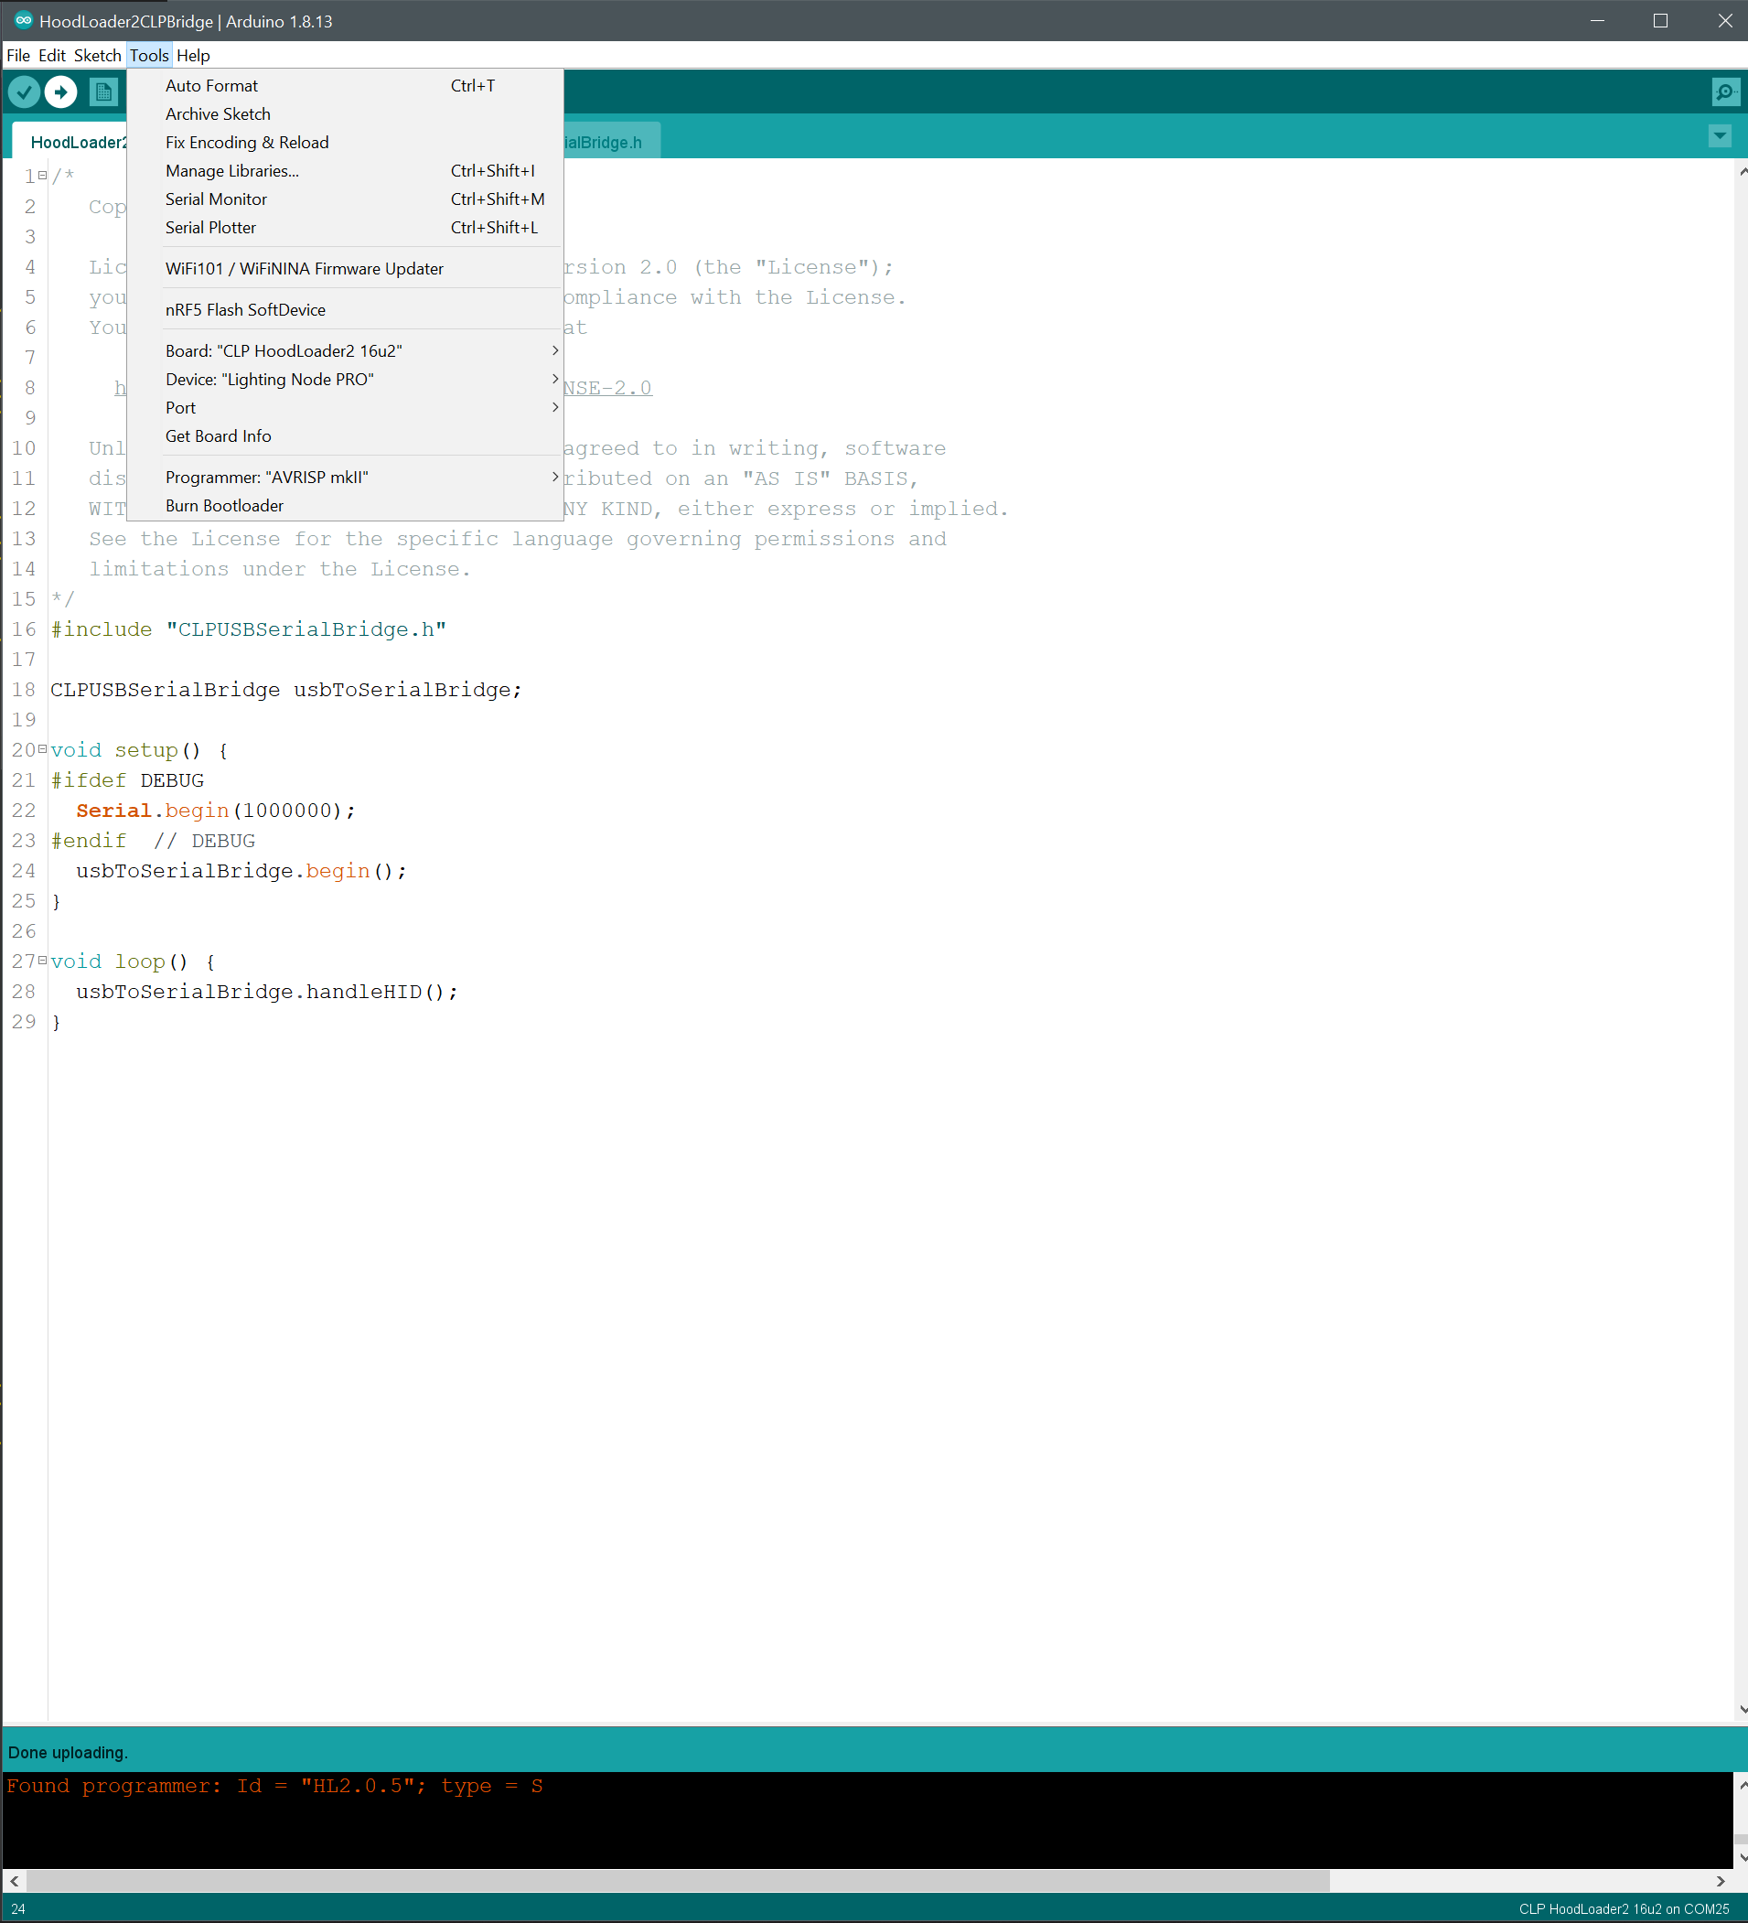

1. Finished.